Internal Project Report for Object Oriented Methodology & Design MCA

Semester: VI

Academic Year 2019-20.

Submitted By:

Group: No: 22

Roll No. Name

MC21954 Priti Santosh Maurya.

MC21956 Shreya Krishna Patil.

Presented on: 3rd March 2020 ---- 30th March/ 1st Aril 2020.

POST GRADUATE DEPARTMENT OF COMPUTER SCIENCE

S. N. D. T. WOMEN’S UNIVERSITY, MUMBAI.

**ACKNOWLEDGEMENT**

I am completely satisfied at this moment to represent my project on Stock management system for Plastic Company. This project has been a learning and challenging process for me. The completion of project would have been unattainable without the assistance and supervision given to me by all the professors of my college & my friends.

|  |  |  |
| --- | --- | --- |
| SR.NO | INDEX TOPIC | PAGE |
|  | **Preliminary Investigation** |  |
| (i) | Proposed system and its advantages |  |
| (ii) | Gantt Chart |  |
|  |  |  |
| **II**. | **System Analysis** |  |
| (i) | Event Table |  |
| (ii) | Use Case Diagram |  |
| (iii) | Activity Diagram |  |
| (iv) | Class Diagram |  |
| (v) | Object Diagram |  |
| (vi) | Sequence Diagram |  |
| (vii) | State Chart Diagram |  |
|  |  |  |
| **III**. | **System Design** |  |
| (i) | Converting ERD to Tables |  |
| (ii) | Component Diagram |  |
| (iii) | Deployment Diagram |  |

INDEX

|  |  |  |
| --- | --- | --- |
| **IV**. | **System Coding** |  |
| (i) | Site Map |  |
| (ii) | List of tables with attributes and constraints |  |
| (iii) | Program Description with Naming Conventions |  |
| (iv) | Screen Layouts |  |
| (v) | Validations |  |
| **V**. | **Future Enhancement** |  |
| **VI**. | **References and Bibliography** |  |

**Preliminary Investigation**

PROPOSED SYSTEM

WORKING:

* The proposed system will be offline, no need of internet connection.
* Admin will be edit or enter the information since it has only single admin panel.
* Handel details of sales, purchase, balance stock
* Keep track of employee’s attendance and generate salary depending on attendance and overtime.
* Deals with day to day requirement of production organization.
* Reports will be created quickly.
* It will reduce human work.

ADVANTAGE OF PROPOSED SYSTEM:

* This system has been developed to be simple and user- friendly. Hence, even a non - technical user can use the system effectively and without any difficulty.
* It is upgradeable. Hence further enhancement to the system is possible.
* The system is capable of generating the necessary report.
* The system maintains speed and accuracy.
* It is easy to understand the system.

Software Requirements

**Back End**

* Microsoft SQL Server 2008/Higher

**Front End**

* Microsoft Visual Studio 2010/Higher

**Others**

* DotNet Framework 3.5/Higher

**System**

**Analysis**

EVENT TABLE

|  |  |  |  |  |  |
| --- | --- | --- | --- | --- | --- |
| **EVENT** | **TRIGGER** | **SOURCE** | **ACTIVITY** | **RESPONCE** | **DESTINATION** |
| Admin  Login | Login | Admin | Checking id & password | Login successful | Admin |
| Employee  profile | Details taken | Employee | Saves  Details | Details saved | Admin |
| Employee  Attendance | Select Employee  Name | Employee | Attendance  Saved | Saved  successfully | Admin |
| Salary | Employee  Salary | Employee | Salary  Calculated | Paid | Admin |
| Supplier | Supplier  Form | Supplier | Details  Added | Saved  successfully | Admin |
| Product | Product  Master | Product | Product  Type added | Added  successfully | Admin |
| Machine | Add machine | Machine | Machine details added | Added successfully | Admin |
| Production | Production Form | Machine | Select production Details | Added | Admin |
| Weight | Add Weight | Machine | Add Weight of product | Wight Added | Admin |
| Order | Order Form | Order | Add order for customer | Order Added | Admin |
| Order List | Order List | Order | Displays today’s orders | Shows List | Admin |
| Order | Order Due | Order | Displays Due orders list | Shows due list | Admin |

Continue…

|  |  |  |  |  |  |
| --- | --- | --- | --- | --- | --- |
| **EVENT** | **TRIGGER** | **SOURCE** | **ACTIVITY** | **RESPONCE** | **DESTINATION** |
| Order | Completed  Order | Order | Displays  List of  Completed orders | Shows List | Admin |
| Sale | Sale | Order | Calculate  Sale & generate bill | Paid | Admin |
| New  Customer | Add new  customer | Sale | Fill details of new customer | Added | Admin |
| Product return | Return product form | Order | Damage product details | Return | Admin |
| Expenses | Expenses form | Expenses | Expenses type and amount details | Saved | Admin |
| Report | Purchase  Report | Purchase | Generates  Purchase report | Shows report | Admin |
| Report | Sale  Report | Sale | Generates  Sale report | Shows report | Admin |
| Report | Expenses  Report | Expenses | Generates  Expenses report | Shows report | Admin |
| Report | Salary  Report | Salary | Generates  Salary report | Shows report | Admin |
| Machine interruption | Machine interruption form | Machine | Saves cause of interruption | Saved details | Admin |

|  |  |  |  |  |  |
| --- | --- | --- | --- | --- | --- |
| **EVENT** | **TRIGGER** | **SOURCE** | **ACTIVITY** | **RESPONCE** | **DESTINATION** |
| Search | Stock | Stock | Searches and displays total stock | Shows search result | Admin |
| Search | Product | Product | Searches and displays product list | Shows search result | Admin |
| Search | Customer | Customer | Displays payment due by customer | Shows search result | Admin |
| Search | Production  Report | Production | Generates production report for selected machine | Shows search result | Admin |
| Search | Customer  Report | Customer | Generates normal bill for customer | Shows search result | Admin |
| Bill | Without GST bill | Customer | Generates bill without GST | Bill generates | Admin |

Continue….

**USE CASE DIAGRAM**

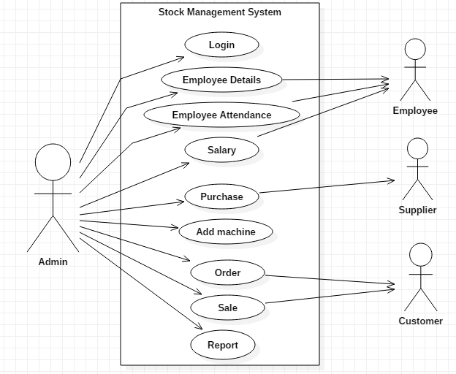

**ACTIVITY DIAGRAM**

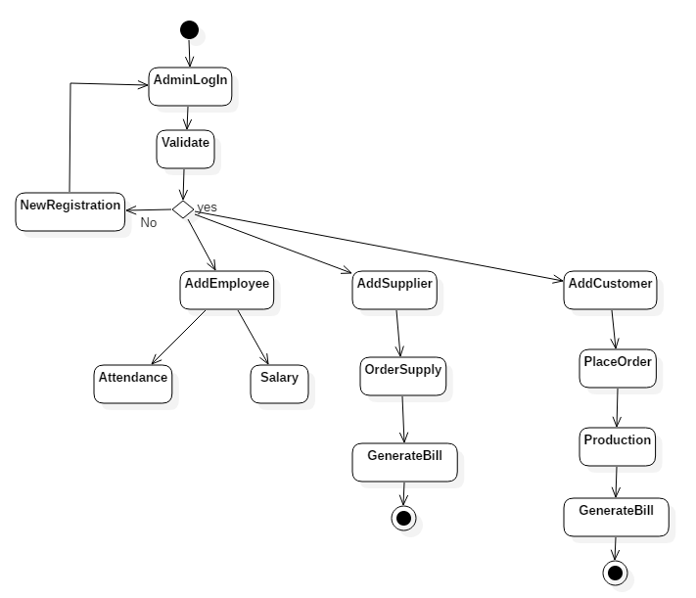

**CLASS DIAGRAM**

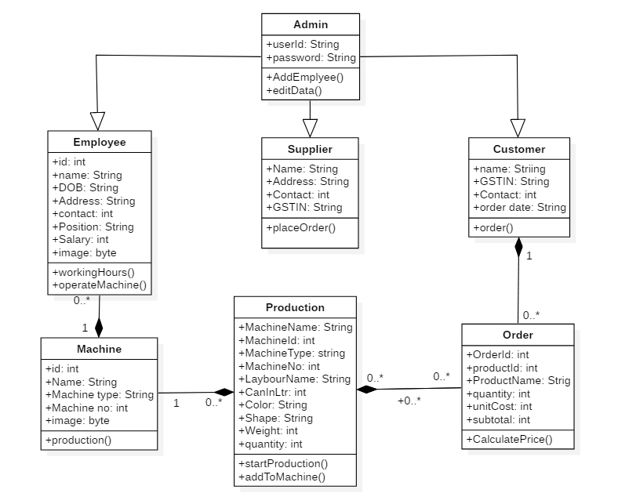

**OBJECT DIAGRAM**

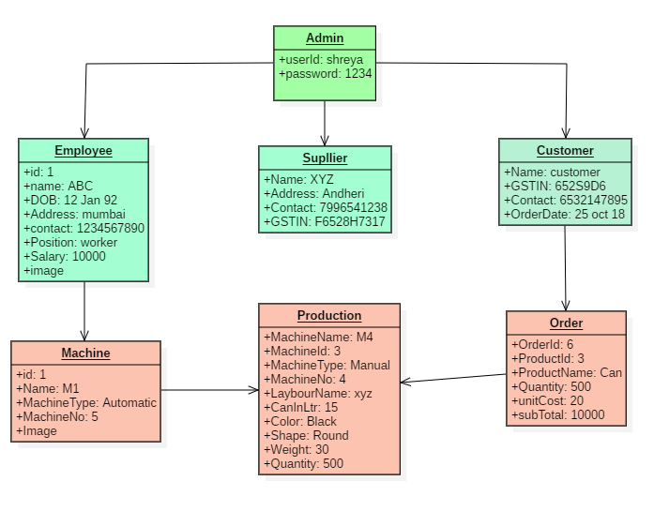

**SEQUENCE DIAGRAM**

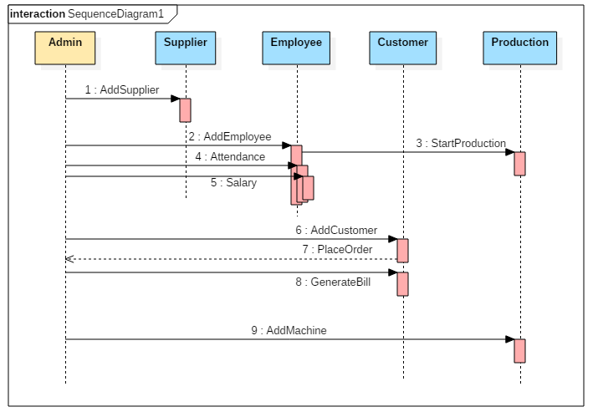

**STATE DIAGRAM**

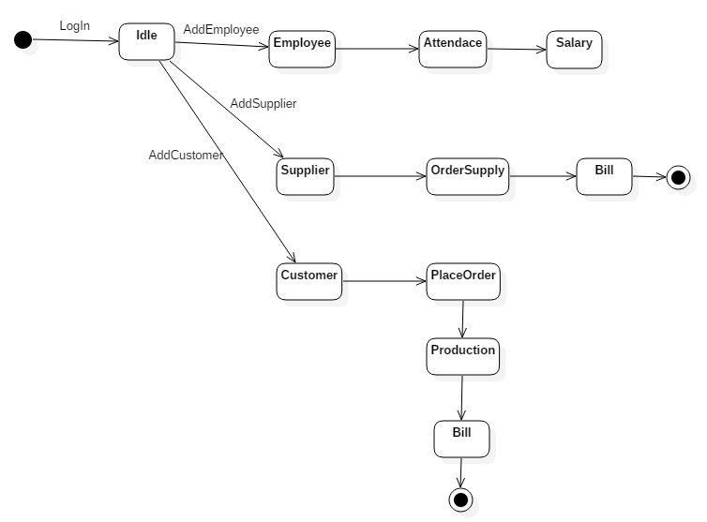

**SYSTEM**

**DESIGN**

**ER DIAGRAM**

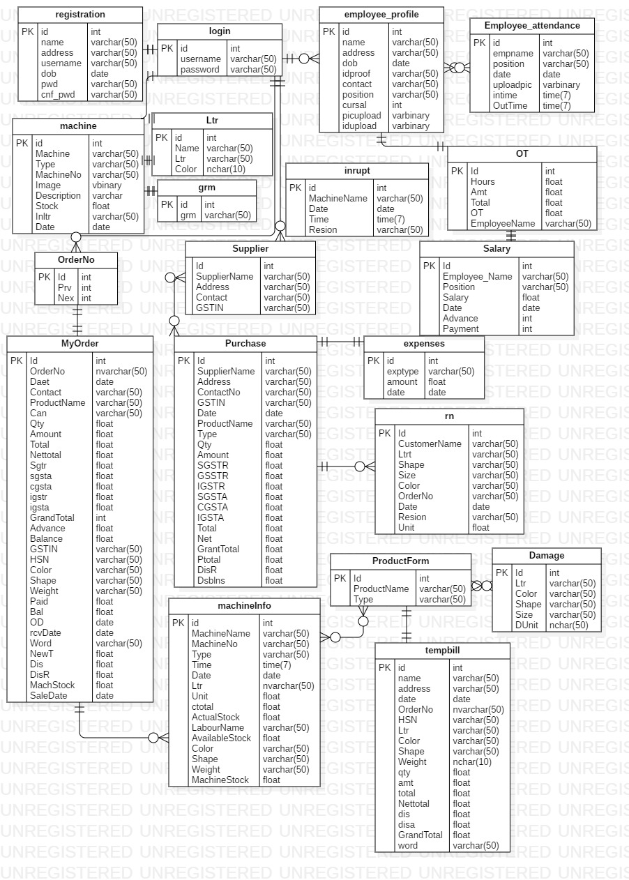

**COMPONENT DIAGRAM**

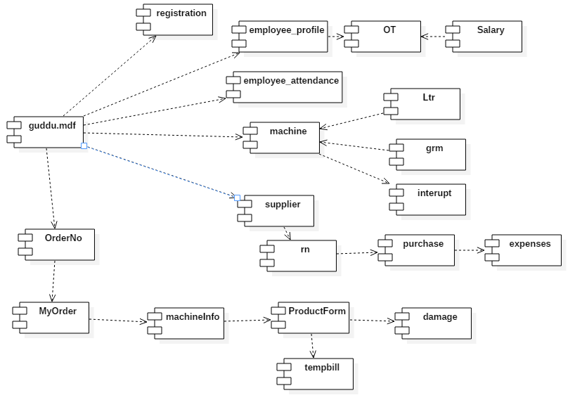

**DEPLOYMENT DIAGRAM**

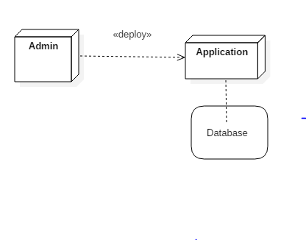

**SYSTEM**

**CODING**

**SITE MAP**

Login

Home Screen

Account New Account

Employee

Employee Profile

Salary

Supplier

Machine Supplier Form

Add machine Product master

Production Purchase

Weight

Order

Sale Order form

Sale Order list

New Customer Order

Product Return Completed Order

Expenses

Machine Interruption

Without GST Bill

Continue…

Home Page

Report

Purchase Report

Sale Report

Expenses Report

Salary Report

Search

Stock

Search by product

Credit Customer

Production report

Search by customer

TABLES WITH ATTRIBUTES AND CONSTRAINTS

1.TABLE NAME: registration

DATABASE NAME: guddu

|  |  |  |  |
| --- | --- | --- | --- |
| KEY | FIELD NAME | DATATYPE | ALLOW NULL |
| PK | Id | Int | no |
|  | name | Varchar(50) | No |
|  | addresss | Varchar(50) | No |
|  | username | Varchar(50) | No |
|  | dob | date | No |
|  | Pwd | Varchar(50) | No |
|  | Cnd_pwd | Varchar(50) | no |

2. TABLE NAME: Login

DATABASE NAME: guddu

|  |  |  |  |
| --- | --- | --- | --- |
| KEY | FIELD NAME | DATATYPE | ALLOW NULL |
| PK | Id | Int | no |
|  | username | Varchar(50) | No |
|  | Password | Varchar(50) | No |

3. TABLE NAME: employee_profile

DATABASE NAME: guddu

|  |  |  |  |
| --- | --- | --- | --- |
| KEY | FIELD NAME | DATA TYPE | ALLOW NULL |
| PK | Id  Name  Address  Dob  Idproff  Contact  Position  Cursal  Picupload  Idupload | Int  Varchar(50)  Varchar(50)  Date  Varchar(50)  Varchar(50)  Varchar(50)  Int  Varbinary  Varbinary | No  No  No  No  No  No  No  No  No  No |

4. TABLE NAME: Employee_attendance

DATABASE NAME: guddu

|  |  |  |  |
| --- | --- | --- | --- |
| KEY | FIELDNAME | DATATYPE | ALLOW NULL |
| PK | Id  Empname  Position  Date  Uploadpic  Intime  outtime | Int  Varchar(50)  Varchar(50)  Date  Varbinary  Time(7)  Time(7) | No  No  No  No  No  No  No |

5. TABLE NAME: machine

DATABASE NAME: guddu

|  |  |  |  |
| --- | --- | --- | --- |
| KEY | FIELDNAME | DATATYPE | ALLOW NULL |
| PK | Id  Machine  TYPE  MachineNo  Image  Description  Stock  Inltr  Date | Int  Varchar(50)  Varchar(50)  Varchar(50)  Varbinary  Varchar  Float  Varchar(50)  date | NO  NO  NO  NO  NO  NO  NO  NO  NO |

6. TABLE NAME: Ltr

DATABASE NAME: guddu

|  |  |  |  |
| --- | --- | --- | --- |
| KEY | FIELDNAME | DATATYPE | ALLOW NULL |
| PK | Id  Name  Ltr  colour | int  Varchar(50)  Varchar(50)  Nchar(10) | NO  NO  NO  NO |

7. TABLE NAME: Grm

DATABASE NAME: guddu

|  |  |  |  |
| --- | --- | --- | --- |
| KEY | FIELDNAME | DATATYPE | ALLOW NULL |
| PK | Id  grm | int  Varchar(50) | NO  NO |

8. TABLE NAME: inrupt

DATABASE NAME: guddu

|  |  |  |  |
| --- | --- | --- | --- |
| KEY | FIELDNAME | DATATYPE | ALLOW NULL |
| PK | Id  MachineName  Date  Time  Resion | int  Varchar(50)  Date  Time(7)  Varchar(50) | NO  NO  NO  NO  NO |

9. TABLE NAME: OT

DATABASE NAME: guddu

|  |  |  |  |
| --- | --- | --- | --- |
| KEY | FIELDNAME | DATATYPE | ALLOW NULL |
| PK | Id  Hours  Amt  Total  OT  EmployeeNme | int  float  float  float  float  Varchar(50) | NO  NO  NO  NO  NO  NO |

10. TABLE NAME: OrderNo

DATABASE NAME: guddu

|  |  |  |  |
| --- | --- | --- | --- |
| KEY | FIELDNAME | DATATYPE | ALLOW NULL |
| PK | Id  Prv  Nex | int  int  int | NO  NO  NO |

11. TABLE NAME: supplier

DATABASE NAME: guddu

|  |  |  |  |
| --- | --- | --- | --- |
| KEY | FIELDNAME | DATATYPE | ALLOW NULL |
| PK | Id  Supplier name  Address  Contact  GSTIN | int  Varchar(50)  Varchar(50)  Varchar(50)  Varchar(50) | NO  NO  NO  NO  NO |

12. TABLE NAME: salary

DATABASE NAME: guddu

|  |  |  |  |  |
| --- | --- | --- | --- | --- |
| KEY | FIELD NAME | | DATA TYPE | ALLOWNULL |
| PK | | Id  EmployeeName  Position  Salary  Date  Advance  Payment | int  Varchar(50)  Varchar(50)  float  date  int  int | NO  NO  NO  NO  NO  NO  NO |

13. TABLE NAME: MyOrder

DATABASE NAME: guddu

|  |  |  |  |
| --- | --- | --- | --- |
| KEY | FIELD NAME | DATA TYPE | ALLOWNULL |

|  |  |  |  |
| --- | --- | --- | --- |
| PK | Id  OrderNo  Date  Contact  ProductName  Can  Qty  Amount  Total  nettotal  sgtr  sgsta  cgsta  igstr  GrandTotal  Advance  Balance  GSTIN  HSN  Color  Shape  Weight  Paid  Bal  OD  rcvDate  Word  newT  Dis  DisR  MachStock  SaleDate | int  nVarchar(50)  date  Varchar(50)  Varchar(50)  Varchar(50)  float  float  float  float  float  float  float  float  int  float  float  Varchar(50)  Varchar(50)  Varchar(50)  Varchar(50)  Varchar(50)  float  float  date  date  varchar(50)  float  float  float  float  float | NO  NO  NO  NO  NO  NO  NO  NO  NO  NO  NO  NO  NO  NO  NO  NO  NO  NO  NO  NO  NO  NO  NO  NO  NO  NO  NO  NO  NO  NO  NO  NO |

14. TABLE NAME: Purchase

DATABASE NAME: guddu

|  |  |  |  |
| --- | --- | --- | --- |
| KEY | FIELDNAME | DATATYPE | ALLOW NULL |
| PK | Id  SupplierName  Address  ContactNo  GSTIN  date  ProductName  Type  Qty  Amount  SGSTR  GSSTR  IGSTR  SGSTA  CGSTA  IGSTA  Total  net  GrandTotal  Ptotal  DisR  Dsbins | int  varchar(50)  varchar(50)  varchar(50)  varchar(50)  date  varchar(50)  varchar(50)  float  float  float  float  float  float  float  float  float  float  float  float  float  float | NO  NO  NO  NO  NO  NO  NO  NO  NO  NO  NO  NO  NO  NO  NO  NO  NO  NO  NO  NO  NO  NO |

15. TABLE NAME: expenses

DATABASE NAME: guddu

|  |  |  |  |
| --- | --- | --- | --- |
| KEY | FIELDNAME | DATATYPE | ALLOW NULL |
| PK | Id  exptype  Amount  date | int  varchar  float  date | NO  NO  NO  NO |

16. TABLE NAME: rn

DATABASE NAME: guddu

|  |  |  |  |
| --- | --- | --- | --- |
| KEY | FIELDNAME | DATATYPE | ALLOWNULL |
| PK | Id  CustomerName  Ltrt  shape  size  color  OrderNo  Date  Resion  unit | int  varchar(50)  varchar(50)  varchar(50)  varchar(50)  varchar(50)  nVarchar(50)  date  varchar(50)  float | NO  NO  NO  NO  NO  NO  NO  NO  NO  NO |

17. TABLE NAME: machineinfo

DATABASE NAME: guddu

|  |  |  |  |
| --- | --- | --- | --- |
| KEY | FIELDNAME | DATATYPE | ALLOWNULL |
| PK | Id  MachineName  MachineNo  type  Time  Date  Ltr  unit  ctotal  ActualStock  LabourName  AvailableStock  shape  color  Weight  MachineStock | int  varchar(50)  vrchar(50)  varchar(50)  time(7)  date  nvarchar(50)  float  float  float  varchar(50)  float varchar(50)  varchar(50)  varchar(50)  float | NO  NO  NO  NO  NO  NO  NO  NO  NO  NO  NO  NO  NO  NO  NO  NO |

18. TABLE NAME: ProductForm

DATABASE NAME: guddu

|  |  |  |  |
| --- | --- | --- | --- |
| KEY | FIELDNAME | DATATYPE | ALLOW NULL |
| PK | Id  ProductName  type | int  varchar(50)  varchar(50) | NO  NO  NO |

19. TABLE NAME: Damage

DATABASE NAME: guddu

|  |  |  |  |
| --- | --- | --- | --- |
| KEY | FIELDNAME | DATATYPE | ALLOW NULL |
| PK | Id  Ltr  color  shape  size  Dunit | int  varchar(50)  varchar(50)  varchar(50)  varchar(50)  nchar(50) | NO  NO  NO  NO  No  No |

20. TABLE NAME: Tempbill

DATABASE NAME: guddu

|  |  |  |  |
| --- | --- | --- | --- |
| KEY | FIELDNAME | DATATYPE | ALLOWNULL |
| PK | Id  Name  address  Date  OrderNo  HSN  shape  color  Weight  qty  amt  total | int  varchar(50)  varchar(50)  date  nvarchar(50)  varchar(50)  varchar(50)  varchar(50)  varchar(50)  float  float  float | NO  NO  NO  NO  NO  NO  NO  NO  NO  NO  NO  NO |

21. TABLE NAME: Grm

DATABASE NAME: guddu

|  |  |  |  |
| --- | --- | --- | --- |
| KEY | FIELDNAME | DATATYPE | ALLOWNULL |
| PK | Id  Name  address  Date  OrderNo  HSN  shape  color  Weight  qty  amt  total  nettotal  dis  disa  GrandTotal  word | int  varchar(50)  varchar(50)  date  nvarchar(50)  varchar(50)  varchar(50)  varchar(50)  varchar(50)  float  float  float  float  float  float  float  varchar(50) | NO  NO  NO  NO  NO  NO  NO  no  no  no  no  no  no  no  no  no  no |

PROGRAM DESCRIPTION

|  |  |
| --- | --- |
| Class Number | 1 |
| Class Name | CompletedOrder.cs |
| Purpose | Shows list of completed orders |
| Input Table | - |
| Output Table | Admin |
| Validations | Accessible to the admin |

|  |  |
| --- | --- |
| Class Number | 2 |
| Class Name | Credit.cs |
| Purpose | Shows balanced payment by customer |
| Input Table | Customer |
| Output Table | Credit |
| Validations | Accessible to the admin |

|  |  |
| --- | --- |
| Class Number | 3 |
| Class Name | DamageGood.cs |
| Purpose | Details about damaged goods |
| Input Table | - |
| Output Table | Damage |
| Validations | Accessible to the admin |

|  |  |
| --- | --- |
| Class Number | 4 |
| Class Name | DeleteOrder.cs |
| Purpose | Cancelation of order |
| Input Table | OrderNo |
| Output Table | - |
| Validations | Accessible to the admin |

|  |  |
| --- | --- |
| Class Number | 5 |
| Class Name | Due.cs |
| Purpose | Displays list of due orders |
| Input Table | OrderNo |
| Output Table | - |
| Validations | Accessible to the admin |

|  |  |
| --- | --- |
| Class Number | 6 |
| Class Name | employee_attendance.cs |
| Purpose | Keeps record of employee attendance |
| Input Table | employee_profile |
| Output Table | employee_attendance |
| Validations | Accessible to the admin |

|  |  |
| --- | --- |
| Class Number | 7 |
| Class Name | employee_profile.cs |
| Purpose | Adds new employee or edit date of previously added employee |
| Input Table | - |
| Output Table | employee_profile |
| Validations | Accessible to the admin |

|  |  |
| --- | --- |
| Class Number | 8 |
| Class Name | expenses.cs |
| Purpose | Adds expenses record |
| Input Table | - |
| Output Table | expenses |
| Validations | Accessible to the admin |

|  |  |
| --- | --- |
| Class Number | 9 |
| Class Name | ExpensesReport.cs |
| Purpose | Shows report for expenses |
| Input Table | - |
| Output Table | - |
| Validations | Accessible to the admin |

|  |  |
| --- | --- |
| Class Number | 10 |
| Class Name | forget_password.cs |
| Purpose | If admin forget password it can be retrieved using forget password |
| Input Table | registration |
| Output Table | - |
| Validations | Accessible to the admin |

|  |  |
| --- | --- |
| Class Number | 11 |
| Class Name | Form1.cs |
| Purpose | Adds machine details |
| Input Table | - |
| Output Table | machine |
| Validations | Accessible to the admin |

|  |  |
| --- | --- |
| Class Number | 12 |
| Class Name | Invoice.cs |
| Purpose | Shows bill |
| Input Table | OrderNo |
| Output Table | - |
| Validations | Accessible to the admin |

|  |  |
| --- | --- |
| Class Number | 13 |
| Class Name | login_form.cs |
| Purpose | Login form |
| Input Table | registration |
| Output Table | - |
| Validations | Accessible to the admin |

|  |  |
| --- | --- |
| Class Number | 14 |
| Class Name | Mach_intrupt.cs |
| Purpose | stores reason for machine interruption |
| Input Table | machine |
| Output Table | intrupt |
| Validations | Accessible to the admin |

|  |  |
| --- | --- |
| Class Number | 15 |
| Class Name | MachineInfo.cs |
| Purpose | Adds production details for machine |
| Input Table | machine |
| Output Table | machineinfo |
| Validations | Accessible to the admin |

|  |  |
| --- | --- |
| Class Number | 16 |
| Class Name | MachineStockReport.cs |
| Purpose | shows report showing stock of machine |
| Input Table | - |
| Output Table | - |
| Validations | Accessible to the admin |

|  |  |
| --- | --- |
| Class Number | 17 |
| Class Name | MDIParent1.cs |
| Purpose | Home screen that gets displayed after user login |
| Input Table | - |
| Output Table | - |
| Validations | Accessible to the admin |

|  |  |
| --- | --- |
| Class Number | 18 |
| Class Name | NewCustomer.cs |
| Purpose | Form to add new customer |
| Input Table | - |
| Output Table | MyOrder |
| Validations | Accessible to the admin |

|  |  |
| --- | --- |
| Class Number | 19 |
| Class Name | OrderForm.cs |
| Purpose | New order form |
| Input Table | - |
| Output Table | MyOrder |
| Validations | Accessible to the admin |

|  |  |
| --- | --- |
| Class Number | 20 |
| Class Name | OrderList.cs |
| Purpose | Displays Order list for selected date |
| Input Table | - |
| Output Table | - |
| Validations | Accessible to the admin |

|  |  |
| --- | --- |
| Class Number | 21 |
| Class Name | Product_Master.cs |
| Purpose | Adds product and it’s type |
| Input Table | - |
| Output Table | ProductForm |
| Validations | Accessible to the admin |

|  |  |
| --- | --- |
| Class Number | 22 |
| Class Name | ProductionReport.cs |
| Purpose | Shows production report |
| Input Table | machine |
| Output Table | - |
| Validations | Accessible to the admin |

|  |  |
| --- | --- |
| Class Number | 23 |
| Class Name | ProductUpdate.cs |
| Purpose | Update production details for selected machine |
| Input Table | machineInfo |
| Output Table | machineInfo |
| Validations | Accessible to the admin |

|  |  |
| --- | --- |
| Class Number | 24 |
| Class Name | Program.cs |
| Purpose | Main entry point for the application |
| Input Table | - |
| Output Table | - |
| Validations | - |

|  |  |
| --- | --- |
| Class Number | 25 |
| Class Name | Purchase.cs |
| Purpose | Purchase form to order supplies |
| Input Table | supplier |
| Output Table | purchase |
| Validations | Accessible to the admin |

|  |  |
| --- | --- |
| Class Number | 26 |
| Class Name | PurchaseReport.cs |
| Purpose | Shows purchase report |
| Input Table | - |
| Output Table | - |
| Validations | Accessible to the admin |

|  |  |
| --- | --- |
| Class Number | 27 |
| Class Name | registration_form.cs |
| Purpose | Admin registration form |
| Input Table | - |
| Output Table | registration |
| Validations | Accessible to the admin |

|  |  |
| --- | --- |
| Class Number | 28 |
| Class Name | retunANddamage.cs |
| Purpose | Details about returned and damaged goods |
| Input Table | OrderNo |
| Output Table | damage |
| Validations | Accessible to the admin |

|  |  |
| --- | --- |
| Class Number | 29 |
| Class Name | Salary.cs |
| Purpose | Calculates employee salary |
| Input Table | employee_profile |
| Output Table | salary |
| Validations | Accessible to the admin |

|  |  |
| --- | --- |
| Class Number | 30 |
| Class Name | SalaryReport.cs |
| Purpose | Shows salary report |
| Input Table | salary |
| Output Table | - |
| Validations | Accessible to the admin |

|  |  |
| --- | --- |
| Class Number | 31 |
| Class Name | Sale.cs |
| Purpose | Sale details for customer |
| Input Table | OrderNo |
| Output Table | sale |
| Validations | Accessible to the admin |

|  |  |
| --- | --- |
| Class Number | 32 |
| Class Name | SaleReport.cs |
| Purpose | Shows sale report |
| Input Table | sale |
| Output Table | - |
| Validations | Accessible to the admin |

|  |  |
| --- | --- |
| Class Number | 33 |
| Class Name | SearchCustomer.cs |
| Purpose | Searches for customer & displays bill |
| Input Table | MyOrder |
| Output Table | - |
| Validations | Accessible to the admin |

|  |  |
| --- | --- |
| Class Number | 34 |
| Class Name | SearchStockByProduct.cs |
| Purpose | Searches for stock by giving shape,size,color details |
| Input Table | - |
| Output Table | - |
| Validations | Accessible to the admin |

|  |  |
| --- | --- |
| Class Number | 35 |
| Class Name | Stock.cs |
| Purpose | Searches stock between given date |
| Input Table | - |
| Output Table | - |
| Validations | Accessible to the admin |

|  |  |
| --- | --- |
| Class Number | 36 |
| Class Name | SuppliesForm.cs |
| Purpose | Form to add new supplier |
| Input Table | - |
| Output Table | supplier |
| Validations | Accessible to the admin |

|  |  |
| --- | --- |
| Class Number | 37 |
| Class Name | Weight.cs |
| Purpose | Adds weight to machine |
| Input Table | - |
| Output Table | grm |
| Validations | Accessible to the admin |

|  |  |
| --- | --- |
| Class Number | 38 |
| Class Name | withoutgstbill.cs |
| Purpose | Generates bill without GST |
| Input Table | OrderNo |
| Output Table | tempbill |
| Validations | Accessible to the admin |

|  |  |
| --- | --- |
| Class Number | 39 |
| Class Name | WithoutGstBillReport.cs |
| Purpose | Shows Bill report |
| Input Table | - |
| Output Table | - |
| Validations | Accessible to the admin |

SCREEN LAYOUTS

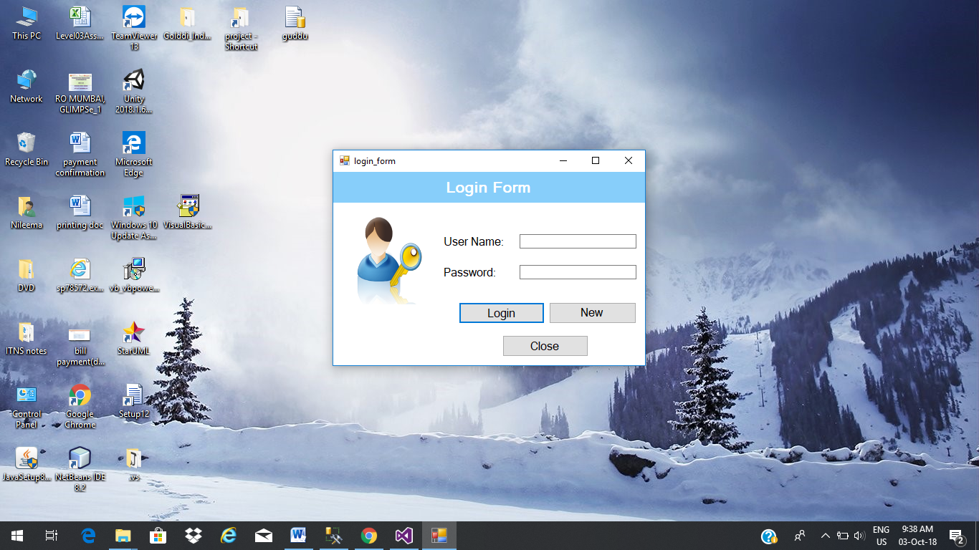

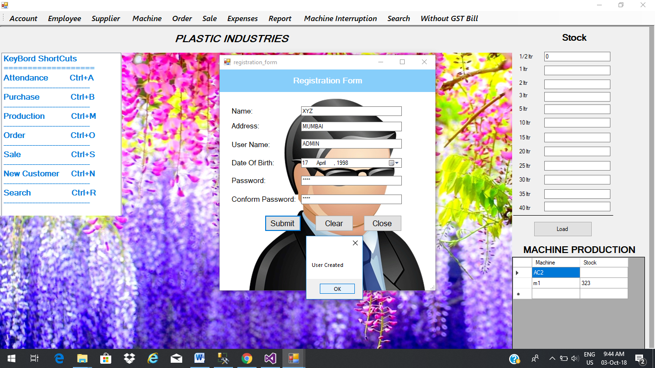

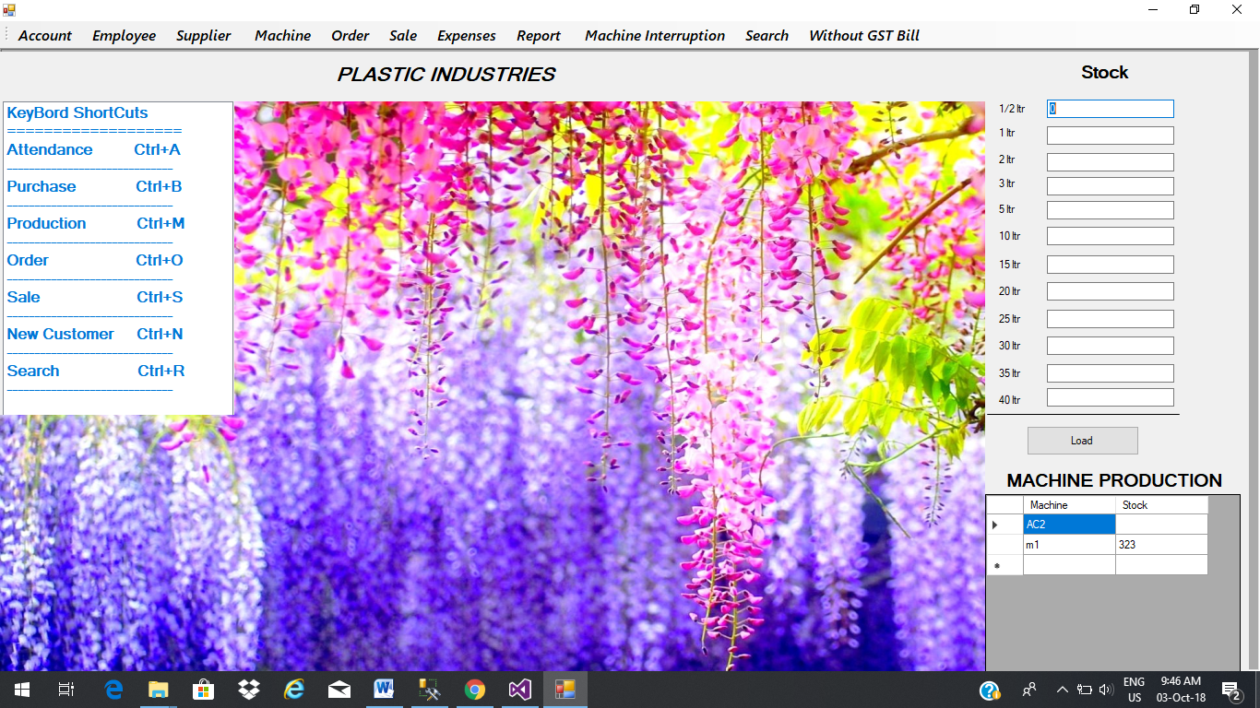

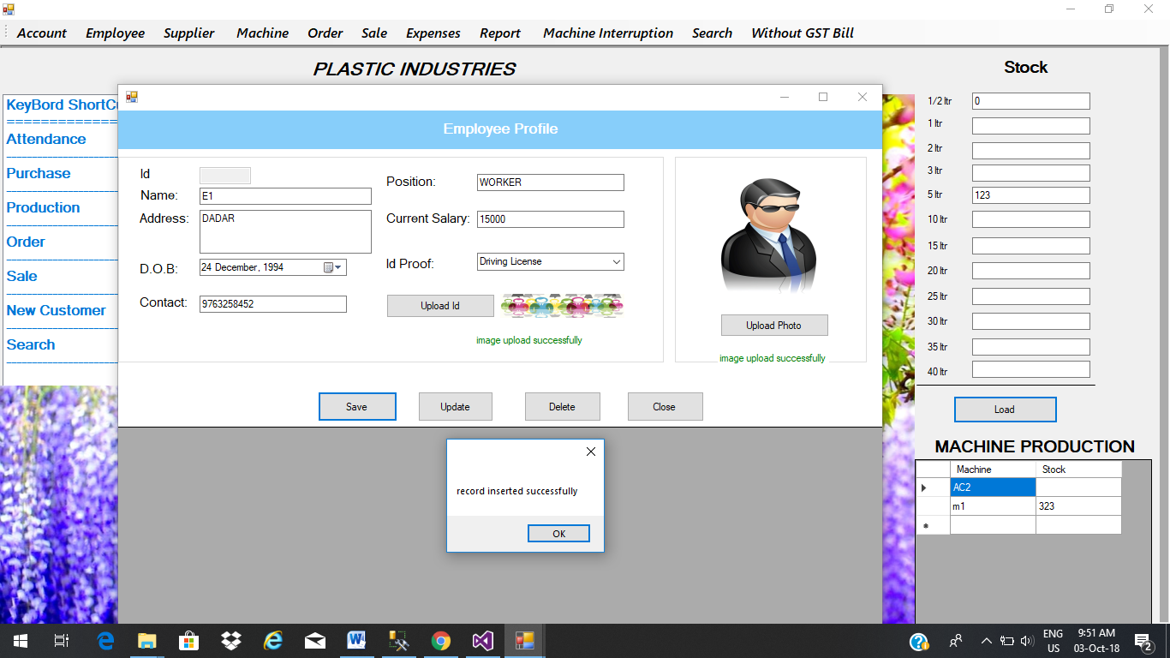

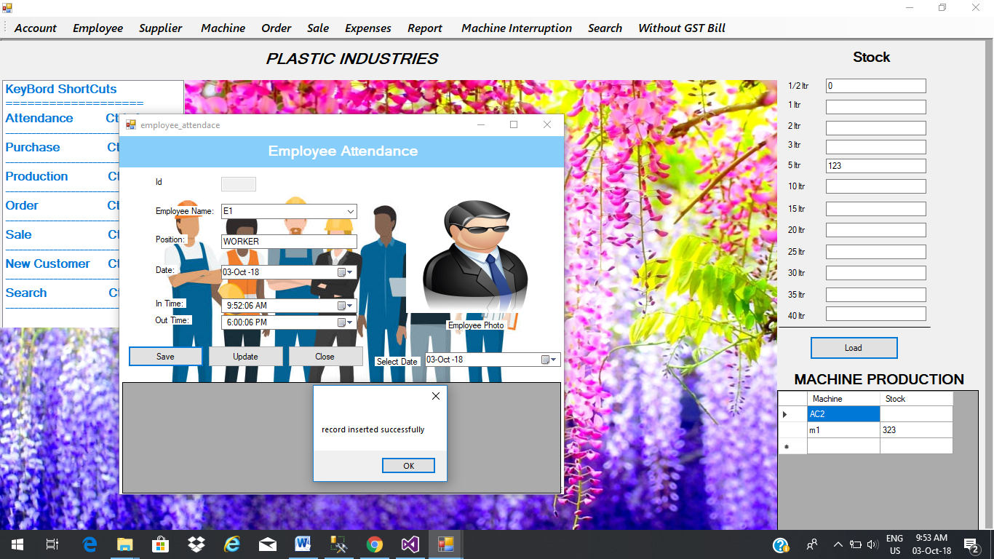

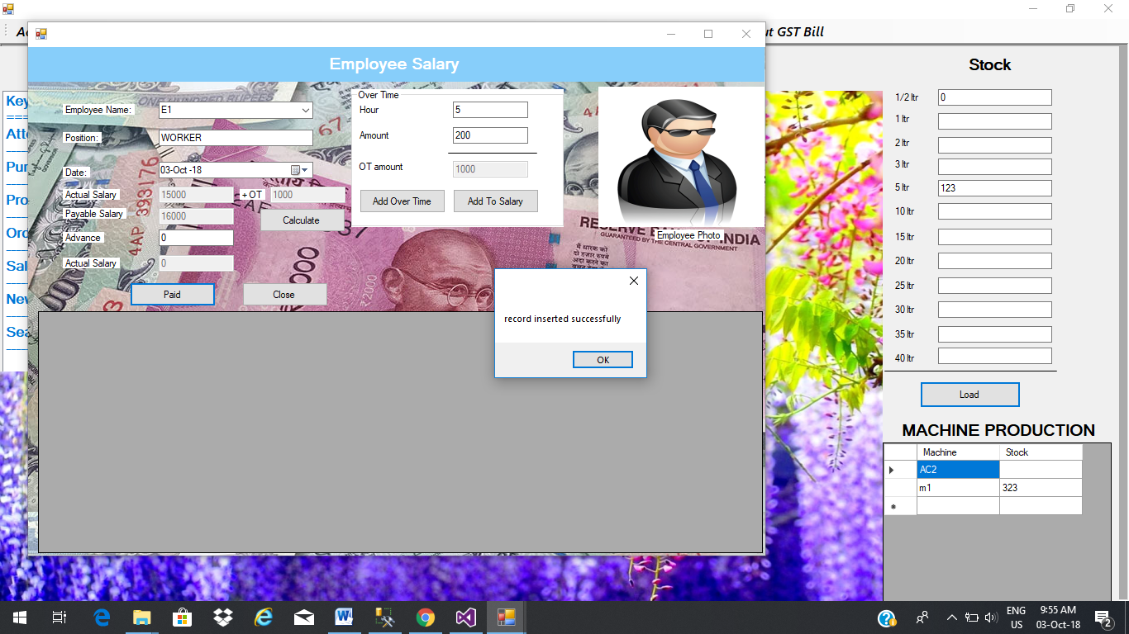

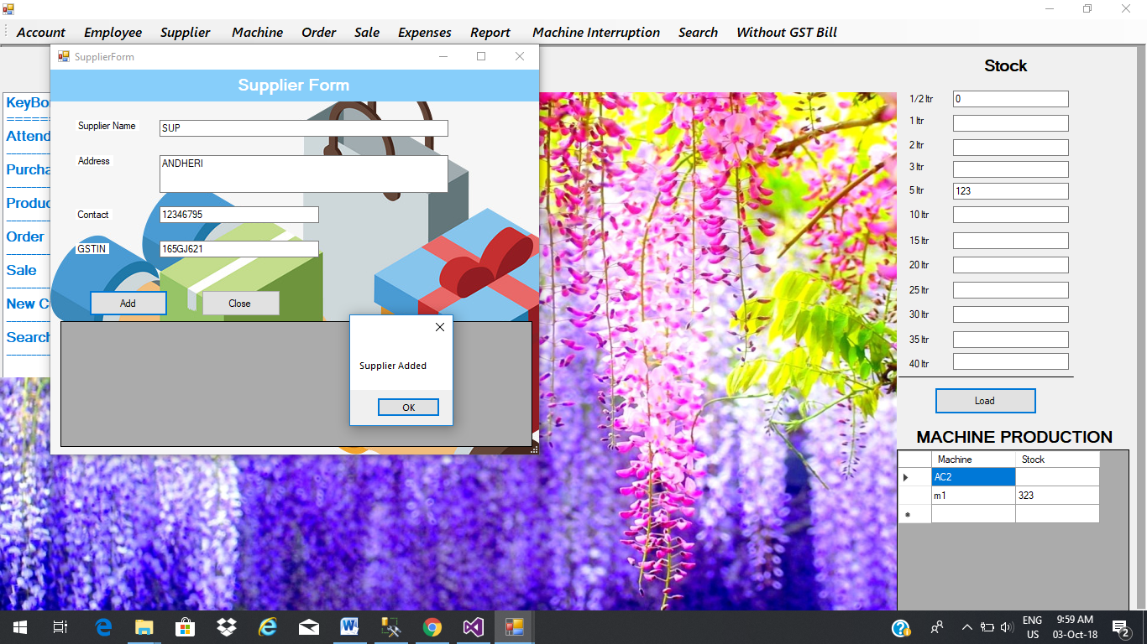

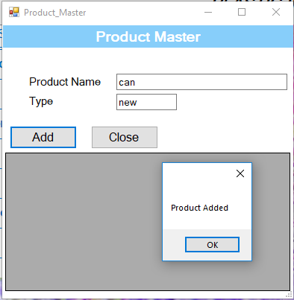

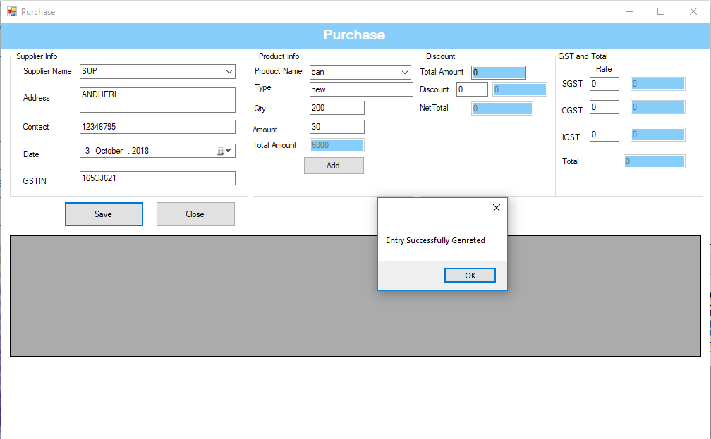

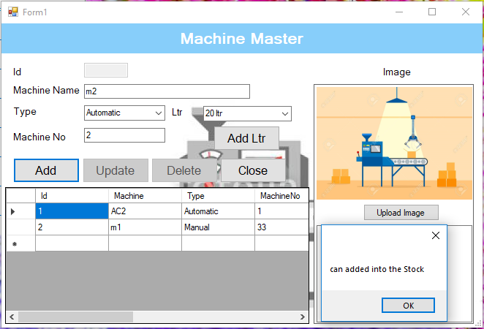

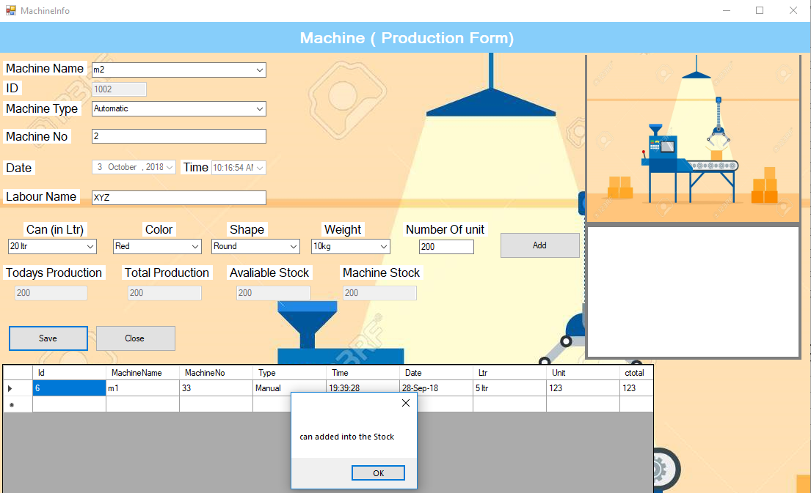

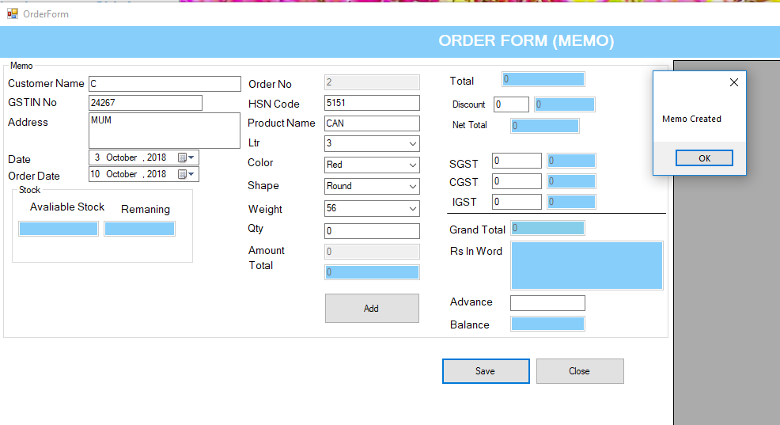

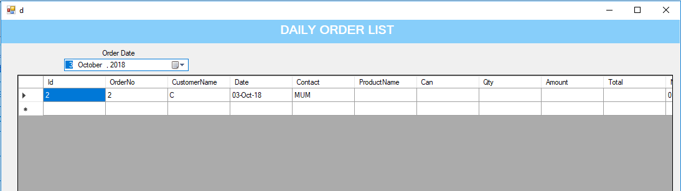

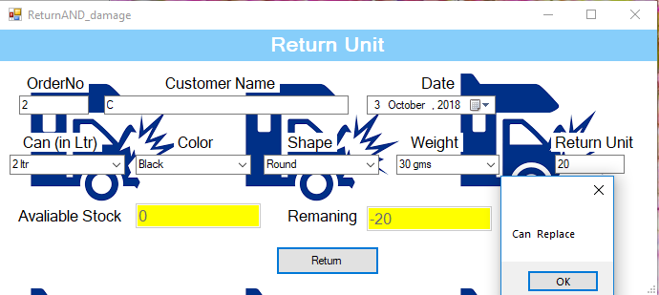

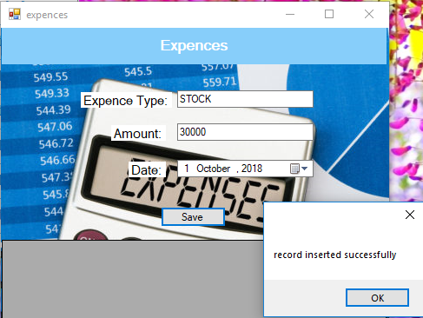

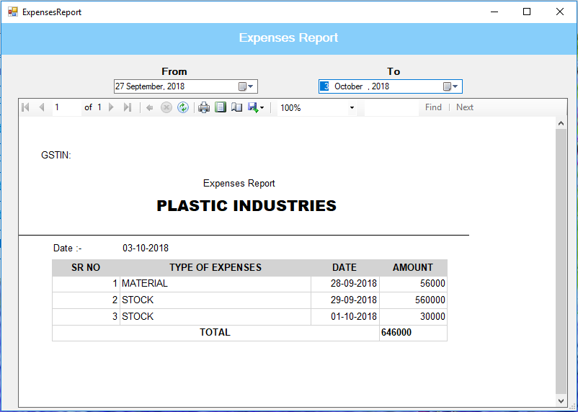

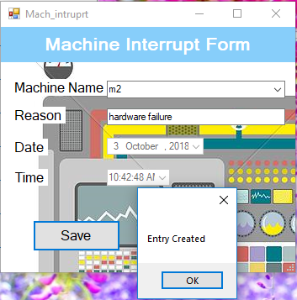

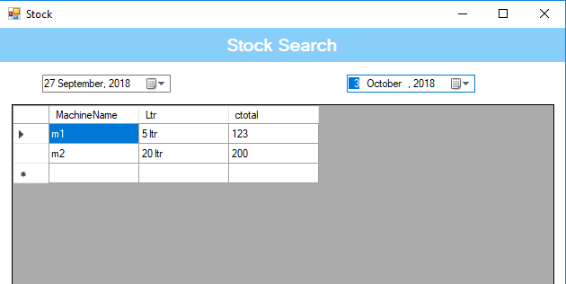

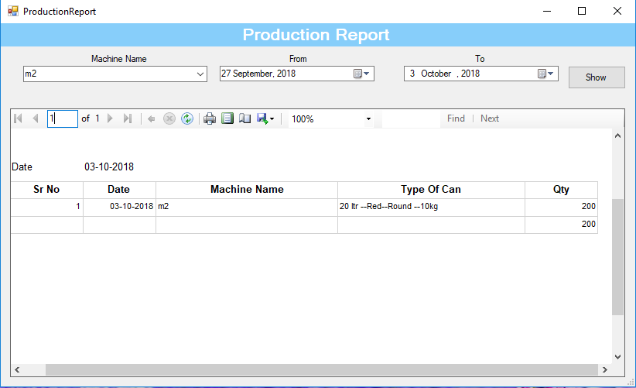

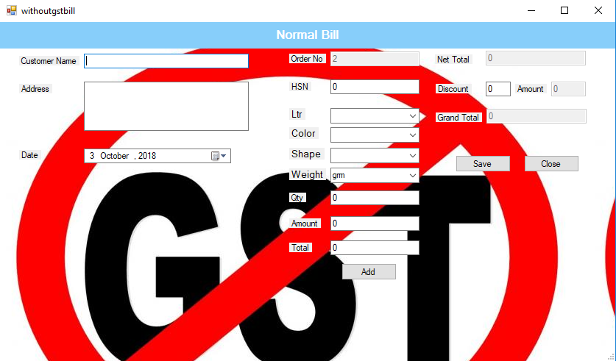

VALIDATIONS

|  |  |  |  |  |  |
| --- | --- | --- | --- | --- | --- |
| Index | Test Case | Test Data | State | Test Input Values | Expected Result |
| 1. | Contact No should accept only 0-9 values | Characters except 0-9 numbers | Invalid | ‘sfr’ | Enter numeric values only |
|  |  |  |  |  |  |
|  |  | Numbers between 0-9 | Valid | 5632147996 | Input is accepted |

|  |  |  |  |  |  |
| --- | --- | --- | --- | --- | --- |
| Index | Test Case | Test Data | State | Test Input Values | Expected Result |
| 2. | The Textbox Should contain only A-Z / a-z | Number or any other Special characters | Invalid | ‘1238as’ | This textbox only accept alphabetical characters |
|  |  |  |  |  |  |
|  |  | Alphabets between A-Z & a-z | Valid | shreya | Input is accepted |

FUTURE ENHANCEMENT

* Most of the project is never completed.
* They always require future enhancement. It is continuous process.
* The project needs to be developing all the time.
* The project is built such that the future enhancements are possible, forms can be easily added and integrated with the project.
* In future we may add e-mail service to mail the bill to customer.

REFERENCE AND BIBLIOGRAPHY

BOOKS REFERRED

SOFTWARE ENGINERR - BY ROGER PRESSMAN

COMPLETE REFERENCE OF VISUAL STUDIO 2010

COMPLETE REFERENCE OF SQL SEREVER 2008

WEBSITE REFERRED

en.wikipedia.org

[www.w3schools.com](http://www.w3schools.com)

[www.google.co.in](http://www.google.co.in)

[www.vbhelp.com](http://www.vbhelp.com)